1) Problem Statement : Write a Static HTML Page that displays self intro.
- HTML CODE :
<!DOCTYPE html>
<html lang="en">
<head>
<meta charset="UTF-8">
<title>Self Introduction</title>
</head>
<body>
<header>
<h1 align="center">Welcome to My Self Introduction Page</h1>
<p>This page gives a brief overview about me, my hobbies, and my daily routine.</p>
</header>
<h1>Self Introduction</h1>
<p>
I'm <strong>Uday Kiran</strong>, a recent B.Tech graduate in
<em>Electronics and Communication Engineering (ECE)</em> at
<strong>BVC Engineering College</strong>. Currently, I am a
<strong>.NET Full Stack Developer with Python trainee</strong>.
</p>
<h2>Hobbies</h2>
<ul>
<li>Playing cricket</li>
<li>Listening to music</li>
</ul>
<h2>Daily Routine</h2>
<ol>
<li>Practice coding</li>
<li>Learn new technologies</li>
</ol>
<h2>Student Details</h2>
<table border="1">
<tr>
<th>Student Name</th>
<th>Subject</th>
<th>Marks</th>
</tr>
<tr>
<td>Uday</td>
<td>Mathematics</td>
<td>85</td>
</tr>
<tr>
<td>Kiran</td>
<td>Science</td>
<td>90</td>
</tr>
</table>
</body>
</html>

- Technical Explanation : This task checks how to build a basic HTML webpage using the correct document structure and common tags to organize content like text, lists, and tables so it displays properly in a browser.

- OUTPUT:
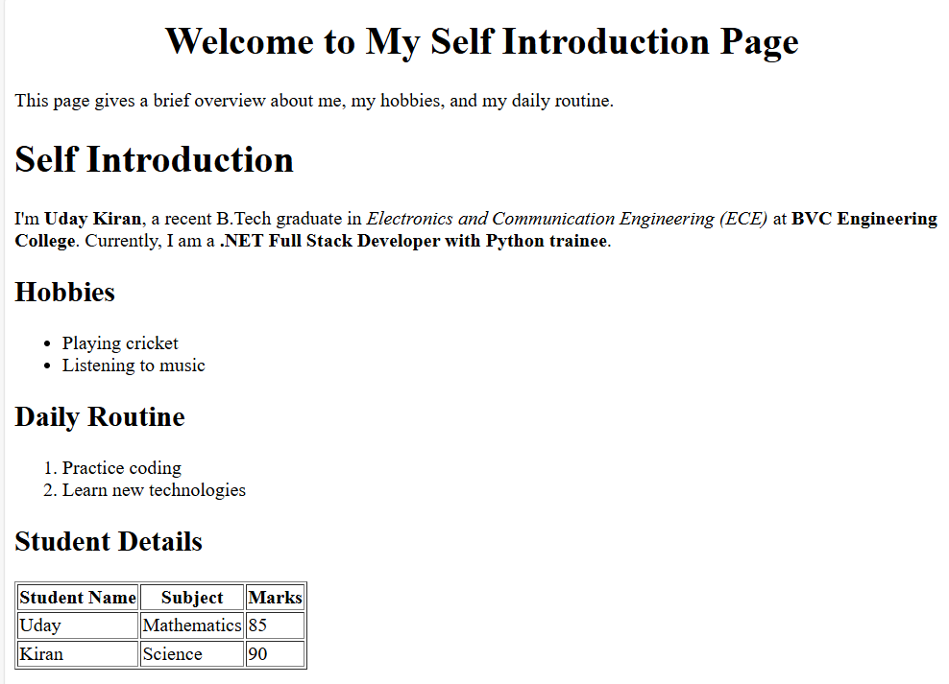

2) Problem Statement : Create a basic HTML restaurant menu webpage displaying restaurant details, menu categories, and a price table using proper HTML structure and elements.
- HTML CODE :
<!DOCTYPE html>
<html lang="en">

<head>
<meta charset="UTF-8">
<title>Tasty Restaurant Menu</title>
</head>

<body>

<h1 align="center">Tasty Restaurant</h1>

<p title="About Us">
Welcome to our Tasty Restaurant. We have a rich tradition and modern flavors. Our chefs use fresh ingredients to bring you fabulous meals at affordable prices.
</p>
<h2>Menu Categories</h2>
<ul>
<li>Main Course</li>
<li>Breakfast</li>
<li>Beverages</li>
<li>Desserts</li>
</ul>

<h2>Price List</h2>
<table border="1" align="center" title="Restaurant Menu">
<tr>
<th>Item Name</th>
<th>Category</th>
<th>Price (₹)</th>
</tr>
<tr>
<td>Paneer Butter Masala</td>
<td>Main Course</td>
<td>220</td>
</tr>
<tr>
<td>Veg Biryani</td>
<td>Main Course</td>
<td>180</td>
</tr>
<tr>
<td>Masala Dosa</td>
<td>Breakfast</td>
<td>90</td>
</tr>
<tr>
<td>Cold Coffee</td>
<td>Beverages</td>
<td>120</td>
</tr>
</table>

</body>

</html>

- Technical Explanation : Use HTML boilerplate with headings, paragraph, unordered list, and a table (with attributes) to structure and display restaurant menu data.

- OUTPUT:
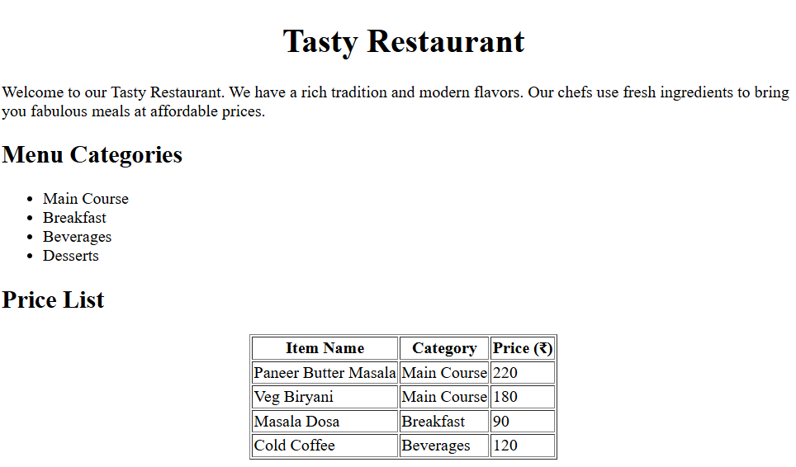
3) Problem Statement : Build a webpage to organize weekly grocery shopping with priority and optional items.

- HTML CODE :
<!DOCTYPE html>
<html lang="en">
<head>
<meta charset="UTF-8">
<title>Weekly Grocery Checklist</title>
</head>
<body title="Plan your weekly grocery shopping easily">
<h1 align="center">Weekly Grocery Checklist</h1>
<h2>High-Priority Items</h2>
<ol>
<li>Rice</li>
<li>Milk</li>
<li>Vegetables</li>
<li>Cooking Oil</li>
</ol>

<h2>Optional Items</h2>
<ul>
<li>Snacks</li>
<li>Ice cream</li>
<li>Soft drinks</li>
</ul>
</body>
</html>

- Technical Explanation :
Use HTML boilerplate with for priority items and for optional items, applying attributes for clarity.

- OUTPUT:

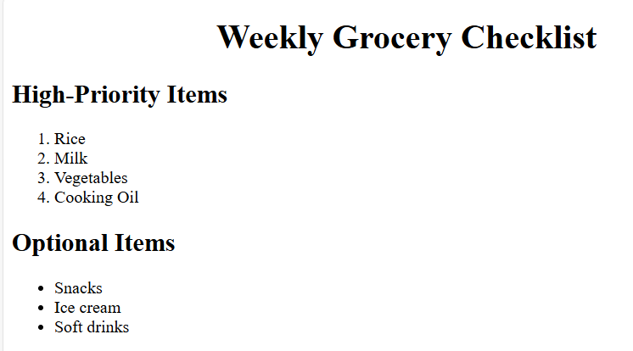

4) Problem Statement : Build a Employee Onboarding Page

- HTML CODE :

<!DOCTYPE html>
<html lang="en">

<head>
<meta charset="UTF-8">
<title>Employee Onboarding</title>
</head>

<body>

<header>
<h1 align="center">Welcome to IT Corporation</h1>
<p>We were excited to have you onboard</p>
</header>

<section>
<h2>Employee Information</h2>
<table border="1">
<thead>
<tr>
<th>Employee ID</th>
<th>Name</th>
<th>Department</th>
<th>Joining Date</th>
</tr>
</thead>
<tbody>
<tr>
<td>23234</td>
<td>Uday Kiran</td>
<td>Human Resources</td>
<td>2026-02-16</td>
</tr>
</tbody>
</table>
</section>

<article>
<h2>Company Policies</h2>
<ol>
<li>Working hours : 9:30 AM to 6:30 PM</li>
<li>Leave policy : 18 paid leaves per year</li>
<li>Code of conduct: Must and should be Professional behavior is expected</li>
</ol>

<h3>Facilities Provided</h3>
<ul>
<li>Laptop</li>
<li>Internet access</li>
<li>Training materials</li>
</ul>
</article>

<footer>
<p>Contact HR at hr@IT.com | Phone: +91 7569999988</p>
</footer>

</body>

</html>

- Technical Explanation :

Semantic HTML improves accessibility, SEO, and code readability by giving meaningful structure to web content.

- OUTPUT:
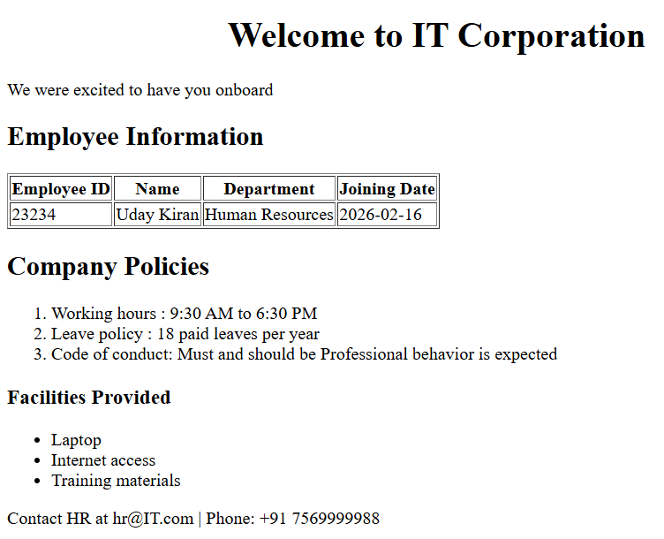
5) Problem Statement : Build a College Department Information Page

- HTML CODE :
<!DOCTYPE html>
<html lang="en">

<head>
<meta charset="UTF-8">
<title>Computer Science Department</title>
</head>

<body>

<header>
<h1 align="center">JNTU College of Engineering</h1>
<h2>Department of Computer Science with AI</h2>
<p>Enthusiastic students with knowledge and innovation.</p>
</header>

<section>
<h3>Faculty Details</h3>

<table border="1">
<tr>
<th>Faculty Name</th>
<th>Designation</th>
<th>Subject Handled</th>
</tr>

<tr>
<td>Dr. Anil Kumar</td>
<td>Professor</td>
<td>Data Structures</td>
</tr>

<tr>
<td>Ms. Sneha Reddy</td>
<td>Associate Professor</td>
<td>DBMS</td>
</tr>

<tr>
<td>Mr. Rahul Verma</td>
<td>Assistant Professor</td>
<td>Operating Systems</td>
</tr>
</table>
</section>
<section>
<h3>Subjects Offered</h3>

<ul>
<li>Data Structures</li>
<li>DBMS</li>
<li>Operating Systems</li>
<li>Computer Networks</li>
<li>Artificial Intelligence</li>
</ul>
</section>
<section>
<h3>Weekly Timetable</h3>

<table border="1">
<tr>
<th>Day</th>
<th>Subject</th>
<th>Time</th>
</tr>

<tr>
<td>Monday</td>
<td>Data Structures</td>
<td>09:00 AM – 10:00 AM</td>
</tr>

<tr>
<td>Tuesday</td>
<td>DBMS</td>
<td>10:00 AM – 11:00 AM</td>
</tr>
<tr>
<td>Wednesday</td>
<td>Operating Systems</td>
<td>11:00 AM – 12:00 PM</td>
</tr> <tr>
<td>Thursday</td>
<td>Computer Networks</td>
<td><time>01:00 PM – 02:00 PM</time></td>
</tr>

<tr>
<td>Friday</td>
<td>Artificial Intelligence</td>
<td><time>02:00 PM – 03:00 PM</time></td>
</tr>

</table>
</section>

<footer>
<p>
JNTU College of Engineering, Mysore <br>
Email: info@jntu.edu <br>
Phone: +91 8885432100
</p>
</footer>

</body>

</html>

- Technical Explanation :
This webpage uses structured HTML elements like tables, lists, and sections to organize academic information clearly for better accessibility and maintainability.

- OUTPUT:
